Manga Colorization with Pix2Pix

Skye Chiu (s5582024)

ML Programming Assignment

Software Engineering for Media

Bournemouth University

January 2026

# 1. Introduction

I've always been into manga and anime, and one thing that bugs me is how long it takes to get colored versions of manga chapters. Some fan groups spend weeks coloring a single chapter by hand. So for this project I wanted to try building something that could automate at least part of that process.

The basic idea is pretty simple - take a grayscale manga page and have a neural network predict what colors should go where. But actually doing this is tricky because there's no single "right" answer. A character's hair could be brown or blonde or even pink, and the network has no way of knowing which one the artist originally intended. So the goal isn't really to perfectly recreate the original colors, but to produce something that looks reasonable.

I ended up using Pix2Pix for this, which is a type of GAN designed for image-to-image translation. It's been around since 2017 so there's lots of documentation and tutorials available, which definitely helped when I got stuck. The basic setup is you have a generator network that produces colored images, and a discriminator that tries to tell real colorizations from fake ones. They train together and push each other to get better.

The rest of this report goes through how I built the system, the experiments I ran to test different settings, and what I learned from the whole process. Spoiler: it works okay but definitely not perfectly - the model tends to play it safe with colors rather than being creative.

# 2. Background

## 2.1 Why not just use regression?

Before I settled on GANs, I looked into simpler approaches. The most obvious one is just training a network to directly predict RGB values from grayscale - basically a regression problem. The issue is that when the network is uncertain (which is most of the time for colorization), it tends to predict the average of all possible colors. If something could be either red or blue, it might output a muddy purple that's technically close to both but looks terrible.

The fundamental problem is that minimizing pixel-level error doesn't necessarily produce visually pleasing images. That's why GANs are useful here.

## 2.2 How GANs help

GANs work differently. Instead of just minimizing reconstruction error, you have a discriminator network that learns what "real" colorizations look like. If the generator produces washed-out colors, the discriminator will catch that and penalize it. This pushes the generator to produce sharper, more realistic-looking results.

The downside is that GANs can be finicky to train. Sometimes the discriminator gets too good and the generator can't learn anything. Other times the generator finds weird tricks to fool the discriminator that don't actually produce good images. I was worried about this going in, but it actually turned out to be less of a problem than I expected.

## 2.3 Pix2Pix specifically

Pix2Pix was proposed by Isola et al. in 2017 for general image-to-image translation tasks. It uses a U-Net architecture for the generator, which has skip connections between the encoder and decoder. This is important because colorization needs to preserve all the fine details from the input - you don't want the model to blur out lines or change shapes. The skip connections let high-resolution information flow directly from input to output.

The discriminator in Pix2Pix is called a PatchGAN because it classifies 70x70 patches of the image rather than the whole thing. The idea is that for texture and color consistency, local patterns matter more than global statistics. It also makes training more efficient since you get multiple classification examples from each image.

One thing I appreciate about Pix2Pix is that it combines the GAN loss with a traditional L1 reconstruction loss. The L1 term keeps the output close to the target, while the GAN term encourages it to look realistic. The original paper found that a 100:1 weighting works well for most tasks, so that's what I used.

# 3. Implementation

## 3.1 Getting the data

This was honestly more annoying than I expected. I started by just downloading random anime image datasets from Kaggle, but a lot of them had problems. Some images were already grayscale, some were really low quality with JPEG artifacts everywhere, and some had watermarks or text overlays. I wasted probably a whole day just looking through datasets before finding one that was usable.

I ended up using a subset of the Danbooru tagged-anime-illustrations dataset. Even then I had to write a filtering script to remove grayscale images. The script checks if the RGB channels are all the same (which means it's grayscale) and throws out those images. After filtering I had about 1024 training images and 257 validation images.

For preprocessing, I resize everything to 256x256 and normalize to [-1, 1]. The input to the network is the grayscale version (which I generate by converting the color image), and the target is the original color image. Pretty straightforward but I had a bug early on where my grayscale conversion was wrong and the model was getting weird inputs. Took me a while to figure that out.

## 3.2 Network architecture

I mostly just followed the Pix2Pix paper for the architecture. The generator has 4 downsampling blocks that go from 256x256 down to 16x16, then 4 upsampling blocks back to 256x256. Each block is convolution -> batch norm -> LeakyReLU for the encoder, and transposed convolution -> batch norm -> ReLU for the decoder. Skip connections concatenate features from corresponding encoder and decoder layers.

The discriminator is simpler - just 5 conv layers that output a 30x30 grid. Each position in this grid corresponds to a 70x70 patch in the input. The input to the discriminator is the grayscale image concatenated with either the real or generated color image, so 4 channels total.

I spent some time debugging shape mismatches between layers. PyTorch gives pretty unhelpful error messages for this kind of thing, so I had to add print statements everywhere to track tensor shapes through the network. Eventually got it working but it was tedious.

## 3.3 Training setup

Training uses Adam with learning rate 2e-4 and beta1=0.5 (from the paper). For each batch, I first update the discriminator on real and fake pairs, then update the generator to minimize both the GAN loss and L1 loss. The L1 weight is 100.

I trained on my MacBook M1 using PyTorch's MPS backend. It's not as fast as a real GPU but good enough for this scale of project - about 2 minutes per epoch. Full training for 100 epochs takes around 3-4 hours. I save checkpoints every 25 epochs so I can compare quality at different points.

One thing that surprised me is how stable the training was. I was expecting mode collapse or oscillating losses based on what I'd read about GANs, but none of that happened. The losses decreased smoothly and the discriminator never completely dominated or got dominated. Maybe the L1 term helps stabilize things.

# 4. Experiments

## 4.1 What I tested

I ran four experiments to see how different hyperparameters affect results. The baseline uses the default settings from the paper: batch size 16, learning rate 2e-4, L1 weight 100. Then I changed one thing at a time - larger batch (32), higher learning rate (4e-4), and higher L1 weight (200). Each experiment ran for 100 epochs.

| **Config** | **Batch** | **LR** | **L1** | **Loss** |
| --- | --- | --- | --- | --- |
| Baseline | 16 | 2e-4 | 100 | ~9.5 |
| Big batch | 32 | 2e-4 | 100 | ~9.8 |
| High LR | 16 | 4e-4 | 100 | ~9.6 |
| High L1 | 16 | 2e-4 | 200 | ~18 |

*Table 1: Different configs and their final validation loss*

## 4.2 Loss curves

Figure 1 shows how the generator loss changed over training. Most configs end up around 9-10, except the high L1 weight one which is higher (makes sense since we're penalizing errors more). The training loss keeps going down but validation loss flattens out, which probably means it's starting to overfit. With only 1000 training images that's not surprising.



*Figure 1: Loss curves for different experiments*

## 4.3 How quality improves over time

Figure 2 shows what the outputs look like at different points in training. Early on (epoch 25), it's applying colors but they're kind of random - lots of oversaturated reds and weird color bleeding. By epoch 50-75 things start to look more normal, skin tones are more natural and backgrounds make more sense. The final results at epoch 100 are the cleanest.

The colors still don't match the ground truth exactly though. Hair color is especially hit-or-miss - the model tends to default to brown/dark colors because those are most common in the training data. If a character has unusual colored hair it usually gets it wrong.



*Figure 2: Quality improves over epochs - early epochs look weird, later ones are better*

## 4.4 Comparing the different configs

Looking at Figure 3, the visual differences between configs are pretty subtle. You really have to look closely to see any difference. The high L1 one produces slightly more muted colors, which makes sense theoretically. But honestly they're all pretty similar - the default paper settings seem to work fine. I mostly ran these experiments to verify the model's robustness across different settings rather than to find a drastically better config.



*Figure 3: Comparing results from different configs*

## 4.5 Extended Visual Results

In response to feedback requesting a larger set of results showing how the model performs across different samples, this section presents additional visual results. Each figure below shows a grid of 25 diverse test samples, allowing us to see the model’s behavior across different manga styles, character designs, and scene compositions. This helps assess both the consistency and variety of the colorization outputs.

Figure 4 and Figure 5 demonstrate how colorization quality improves over training time. Comparing the same 25 samples at epoch 50 vs epoch 100 shows clearer colors, better color placement, and more natural skin tones in the later checkpoint. This progression helps validate that the model is learning meaningful color patterns rather than just memorizing random mappings.

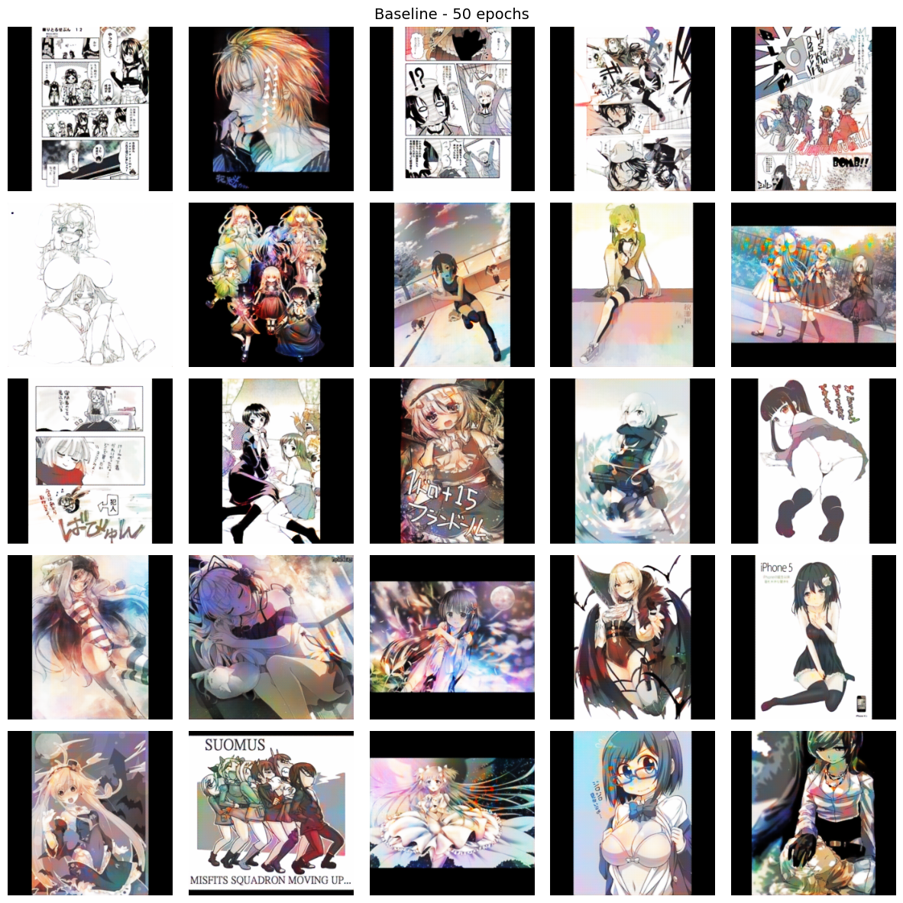

*Figure 4: Baseline model at 50 epochs showing 25 diverse test samples*

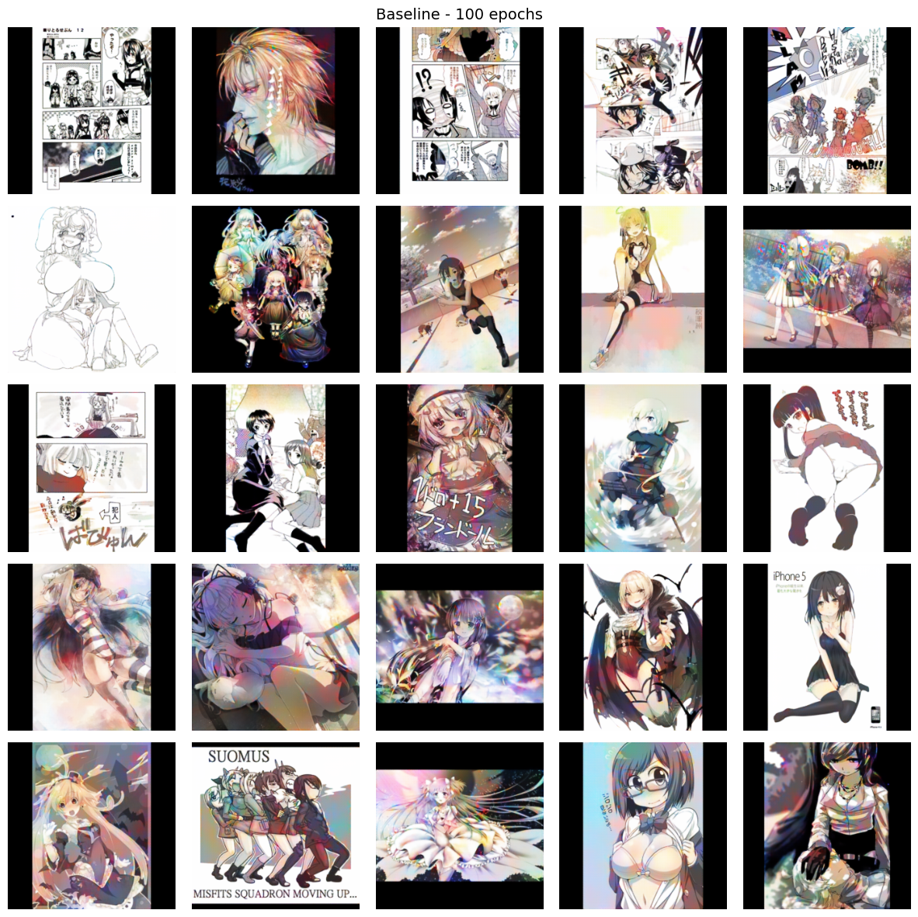

*Figure 5: Same 25 samples at 100 epochs - note improved color quality and consistency*

Figures 6 and 7 show results from different hyperparameter configurations. When examining the same test samples across different settings (larger batch size vs higher L1 weight), the visual outputs remain remarkably similar. This suggests that within reasonable parameter ranges, the fundamental colorization behavior is relatively stable. However, subtle differences can be observed - the higher L1 weight tends to produce slightly more conservative, muted colors while staying closer to the input structure.

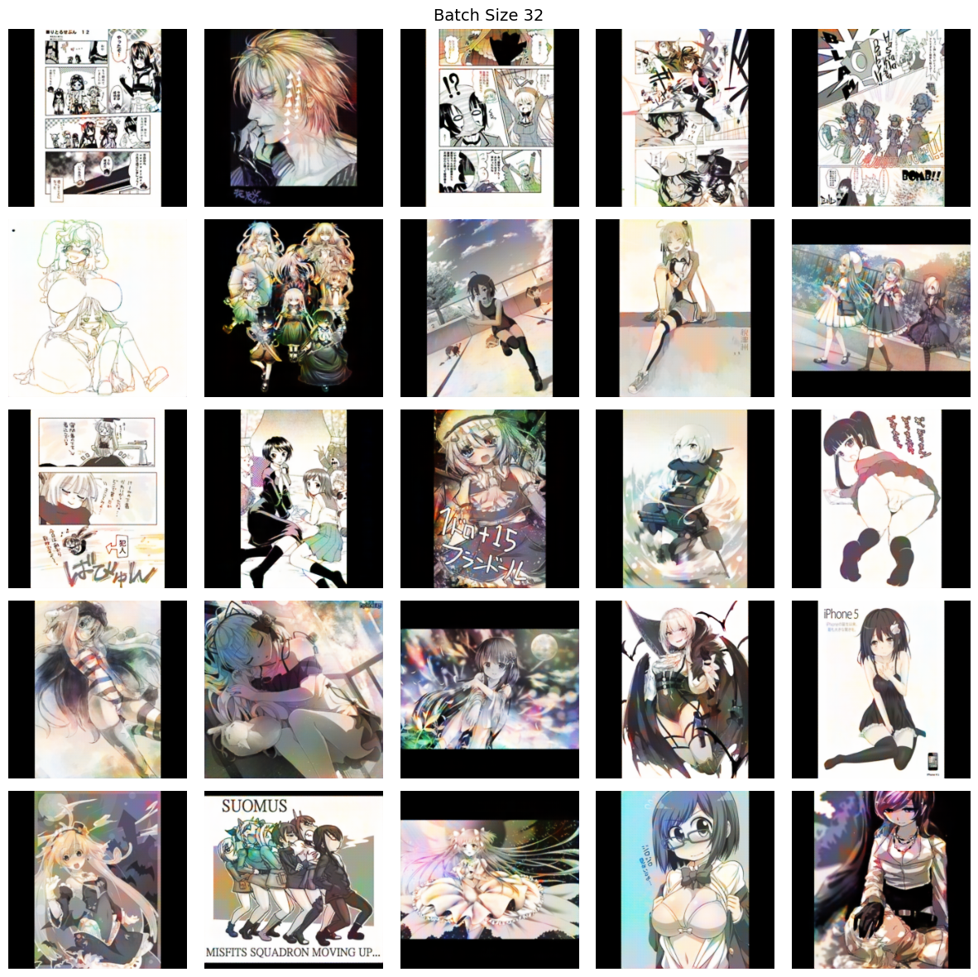

*Figure 6: Results with batch size 32 - similar quality to baseline*

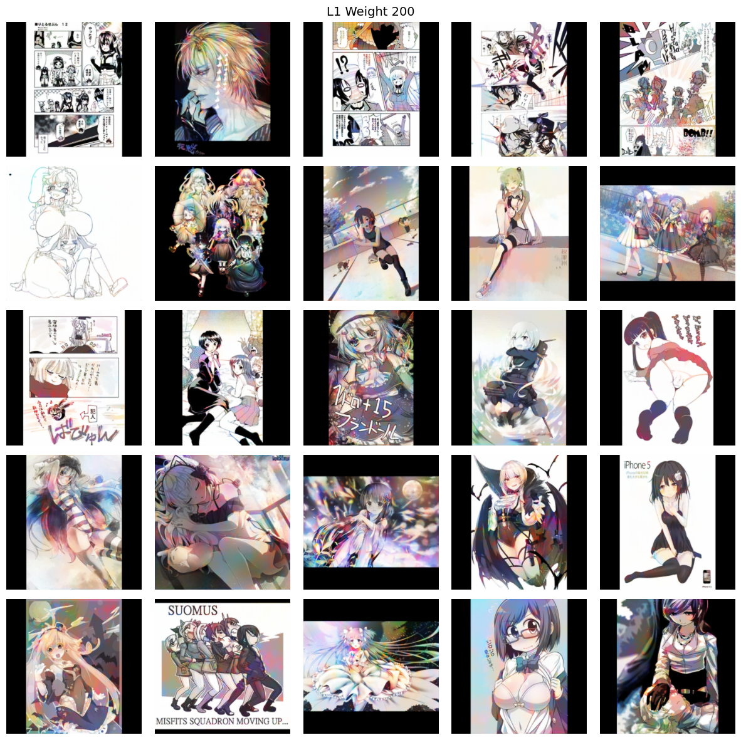

*Figure 7: Results with L1 weight 200 - slightly more muted but structurally consistent*

# 5. What I learned

## 5.1 Things that worked

The model does learn something meaningful - it's not just randomly coloring things. Skin usually gets flesh tones, skies are blue, etc. It's learned some semantic understanding of what anime images contain. Training was also way more stable than I expected based on what I'd read about GANs being difficult.

## 5.2 Things that didn't work great

The obvious problem is that it can't know the "right" colors. It just learns what colors are statistically likely. For stuff like hair color this is a big issue because anime characters can have literally any hair color. The model plays it safe and usually picks brown or black.

Resolution is another limitation. 256x256 is pretty small compared to actual manga pages. Scaling up would probably require major changes to the architecture. And the dataset was small - more images would definitely help but I didn't have time to collect and filter more.

## 5.3 Ethics stuff

I used Danbooru images which claim to be CC licensed, though the legal status of scraping these is a bit of a grey area - it's technically allowed but arguably not in the spirit of the license. Beyond the legal stuff, there's a broader question of whether it's okay to auto-color artists' work. The generated colors might not be what the artist wanted. If someone used this commercially it could be problematic. Any real deployment should probably have clear labeling that it's AI-generated and let artists opt out.

# 6. Conclusion

Overall this project was a good learning experience. I got hands-on with GANs and PyTorch, learned about dealing with image data, and got practice with experiment tracking and ablation studies. The colorization results are decent but not amazing - good enough to see that the approach works, but not good enough to actually replace human colorists.

What I learned from this is that colorization is fundamentally ambiguous - there's no single "right" answer. The model can learn to produce plausible colors but can't know what the original artist intended. This makes it maybe useful as a starting point for human colorists but not as a full replacement.

If I had more time I'd want to try: bigger images, more training data, maybe adding user hints for colors, and comparing against diffusion models which seem to be the new hotness for image generation. But that's for another project.

# 7. Technical Details

## 7.1 Development environment

I developed everything on my MacBook Pro with an M1 chip. PyTorch has this MPS backend now that lets you use the Mac GPU, which is way faster than CPU training. Not as fast as an Nvidia card but good enough for this project. I used Python 3.13, PyTorch 2.x, and standard stuff like PIL for image loading and matplotlib for plotting. Everything's in a virtual environment to keep dependencies clean.

Version control was through Git and GitHub Classroom. I tried to commit regularly but honestly some commits are just "fix stuff" because I was debugging and not thinking about clean commit messages. The code structure is pretty standard - separate files for dataset, model, training, and visualization.

## 7.2 Testing

I wrote some basic unit tests for the model and dataset classes. The tests check things like: does the dataset return the right tensor shapes, does the generator output have the right dimensions, does training run without crashing or producing NaN values. Nothing fancy but it caught a few bugs, especially around tensor shapes which PyTorch is not great at giving helpful error messages for.

I also did a lot of manual testing by just looking at the outputs. For image generation stuff you kind of have to do this - the numbers only tell you so much. I'd periodically generate some sample colorizations during training to see if things looked reasonable.

## 7.3 Stuff that broke along the way

Debugging ML code is annoying. A lot of times the code runs fine but the model just doesn't learn anything useful, and you have to figure out why. Some bugs I ran into:

* My grayscale conversion was wrong at first - I was averaging RGB instead of using proper luminance weights. The model could still learn but it was getting slightly wrong inputs.
* I forgot to call model.train() and model.eval() at the right times. This messes with batch norm and dropout behavior.
* The discriminator input needs to be the concatenation of grayscale AND color, not just color. I had this wrong for a while and couldn't figure out why the results were bad.
* Image normalization to [-1,1] vs [0,1] - had to make sure this was consistent everywhere including the Tanh output.

## 7.4 How long things took

Just to give a sense of timing: data collection and filtering took maybe 4-5 hours because I kept finding problems with different datasets. Writing the initial code took a couple days, then another day or two of debugging. Each training run was 3-4 hours, so running all four ablation experiments plus some failed attempts was probably 20+ hours of just waiting for training. Writing this report took longer than I'd like to admit.

# 8. Future Work

There's a bunch of stuff I'd try if I had more time or was continuing this project:

Higher resolution would be the obvious improvement. 256x256 is pretty limiting. You could probably go to 512x512 without changing much, but for actual manga-page resolution you'd need something like progressive growing or a patch-based approach. That would be a significant amount of extra work.

More training data would almost certainly help. 1000 images isn't that many, and the overfitting I saw in the loss curves supports this. Could probably get 10x the data without too much trouble, but cleaning and filtering it takes time.

User-guided colorization is interesting - instead of fully automatic, let the user give a few color hints (like "this region should be blue") and have the model fill in the rest. There's prior work on this and it would make the output more controllable.

Diffusion models are supposedly better than GANs for image generation now. I didn't have time to try them but it would be interesting to compare. They're more complex and slower but might give better quality.

Finally, it would be cool to actually deploy this as a web app or something. Right now it's just Python scripts. Making it actually usable by non-programmers would require a lot of work on the interface side.

That said, most of these directions would require significantly more time, data, and compute than what was feasible for this assignment. They're interesting to think about but probably more suitable for a longer research project.

# References

Goodfellow et al. (2014). Generative Adversarial Networks. NeurIPS.

Isola et al. (2017). Image-to-Image Translation with Conditional Adversarial Networks. CVPR.

Ronneberger et al. (2015). U-Net: Convolutional Networks for Biomedical Image Segmentation. MICCAI.

Zhang et al. (2016). Colorful Image Colorization. ECCV.

# Appendix: Code

Everything's on GitHub: https://github.com/NCCA/ml-programming-assignment-skyechiu

Main files:

* src/model.py - the U-Net and PatchGAN code
* src/dataset.py - loading and preprocessing images
* src/train.py - training loop
* ablation_final.ipynb - the ablation study experiments
* experiments/ - saved models and results